TEST REPORT – DEMOBLAZE AUTOMATION TESTING

1. Project Information
Field | Details
Project Name | DemoBlaze Automation Testing
Test Plan ID | TP-DEMO-001
Tester | Jeshma Veera Monteiro
Test Type | Functional & Automation Testing
Tools Used | Selenium WebDriver, Java, TestNG, Maven
Framework | Page Object Model (POM)
Environment | Chrome, Windows 10+
Application URL | https://www.demoblaze.com/
Execution Date | 12/09/2026

2. Objective
- Validate core e-commerce functionalities.
- Verify Signup and Login functionality.
- Verify product browsing and category functionality.
- Validate Product Details functionality.
- Verify Add to Cart functionality.
- Verify cart product information and cart total calculation.
- Verify Delete functionality.
- Validate checkout and purchase functionality.
- Test negative scenarios and input validation.
- Identify functional and UI defects.
- Ensure application stability through automation testing.

3. Test Execution Summary
Metric | Count
Total Test Cases | 275
Executed Manually | 275
Automated | 177
Passed | 248
Failed/ Defects Identified | 27

4. Modules Covered
- Signup
- Login/ Logout
- Home Page
- Product Categories
- Product Details
- Cart
- Checkout / Purchase
- Contact
- About Us
- Pagination
- Navigation

5. EXECUTION SCREENSHOTS

5.1 Signup Execution

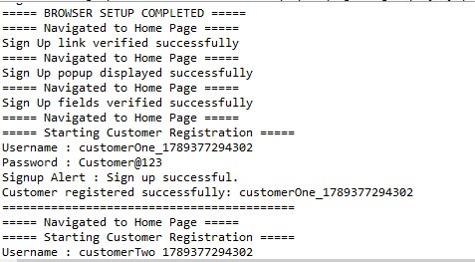

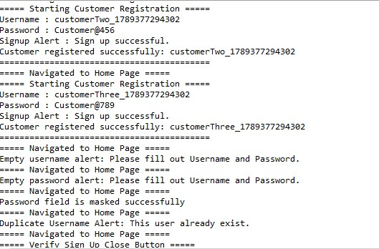

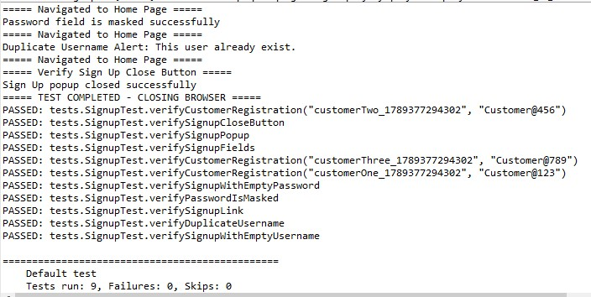
Description:
User opens the Signup option and enters valid registration details.
Expected:
Signup form should be displayed and valid user details should be accepted.
Actual:
Signup functionality executed successfully.
Status: PASS

5.2 Login Execution
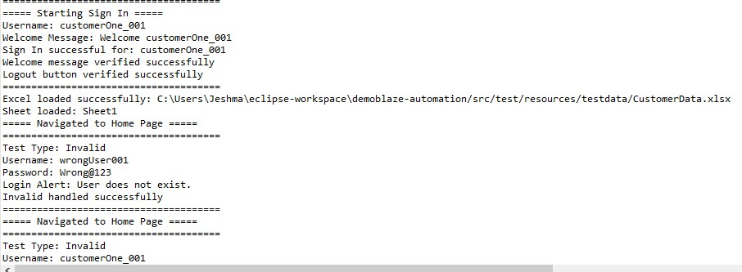
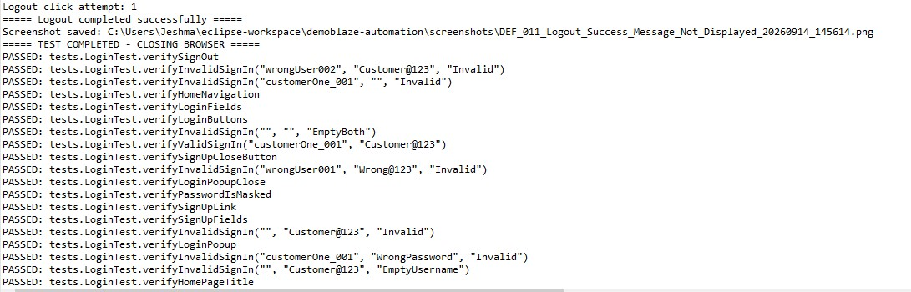Description:
User enters valid username and password and attempts to log in.
Expected:
User should be logged in successfully.
Actual:
Login functionality worked successfully.
Status: PASS

5.3 Home Page Execution
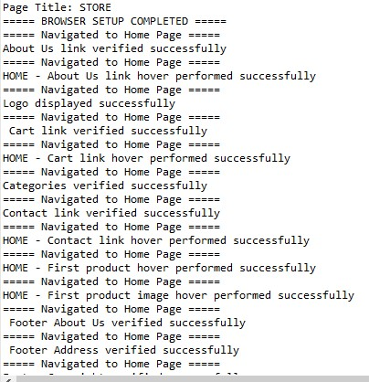
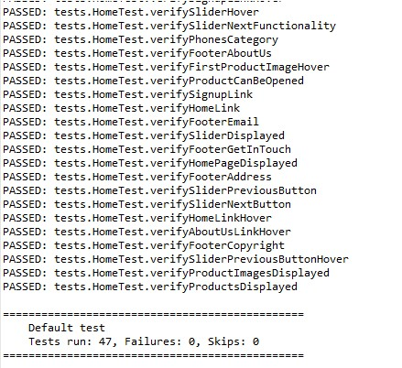

Description:
Home page was opened and major UI elements were verified.
Expected:
Home page should load successfully with navigation links, categories and products.
Actual:
Home page loaded successfully and major elements were displayed.
Status: PASS

5.4 Product Category Execution

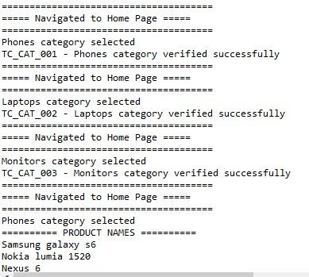

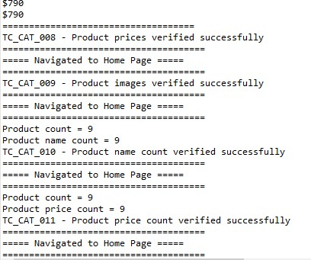
Description:
Phones, Laptops and Monitors categories were selected and products were verified.
Expected:
Products belonging to the selected category should be displayed.
Actual:
Products were displayed under the respective categories.
Status: PASS

5.5 Product Details Execution
Screenshot:
[Insert Product Details screenshot here]
Description:
A product was opened and product information was verified.
Expected:
- Product name should be visible.
- Product price should be visible.
- Product image should be displayed.
- Product description should be displayed.
- Add to Cart button should be available.

Actual:
Product details were displayed successfully.
Status: PASS

5.6 Add to Cart Execution

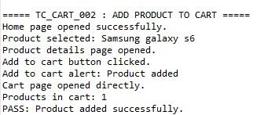
Description:
User selects a product and clicks Add to Cart.
Expected:
Selected product should be added to the cart.
Actual:
Product was successfully added to the cart.
Status: PASS

5.7 Cart Execution
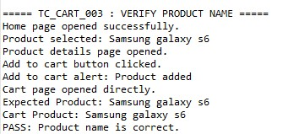
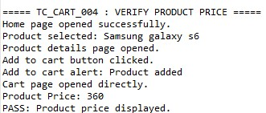
Description:
Cart functionality was tested by checking the empty cart, adding a product, and verifying cart information.
Expected:
- Empty cart should contain no products.
- Added product should be displayed.
- Product name , price should be visible..
- Cart total should be displayed.
Actual:
Cart product information and price were displayed successfully.
Status: PASS

5.8 Cart Delete Execution
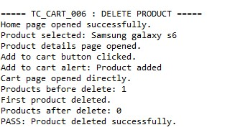
Description:
A product was deleted from the cart.
Expected:
Selected product should be removed from the cart.
Actual:
Product was successfully removed.
Status: PASS

5.9 Cart Total Validation
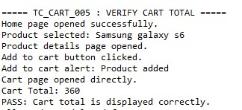
Description:
The cart total was verified after adding a product.
Expected:
Cart total should correctly represent the product price.
Actual:
Cart total was displayed correctly.
Status: PASS

5.10 Empty Cart Checkout – DEFECT
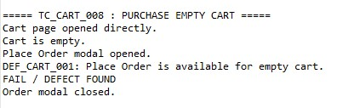
Description:
The Place Order option was tested when the cart contained no products.
Expected:
User should not be allowed to proceed to checkout with an empty cart.
Actual:
Place Order option can be accessed even when the cart is empty.
Defect: DEF_CART_001
Severity: Critical
Priority: High
Status: Open

5.11 Checkout / Purchase Execution
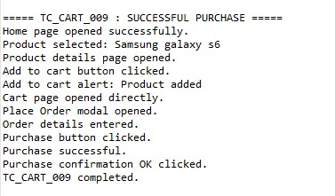

Description:
A product was added to the cart and a valid order was submitted.
Expected:
Purchase should be completed successfully after entering valid mandatory information.
Actual:
Purchase was completed successfully.
Status: PASS

5.12 Blank Checkout Fields
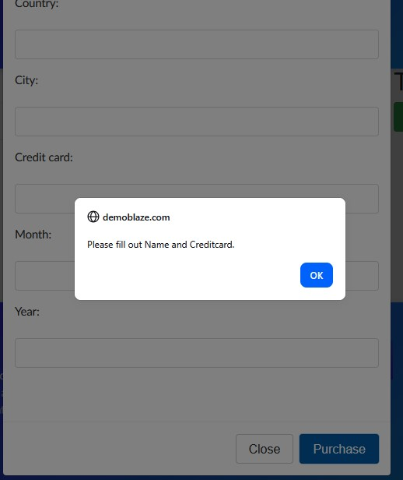

Description:
Purchase was attempted without entering mandatory checkout information.
Expected:
System should validate mandatory fields and prevent purchase when required information is blank.
Actual:
Record the actual behavior from your execution here.
Status: PASS / FAIL

5.13 Contact Execution
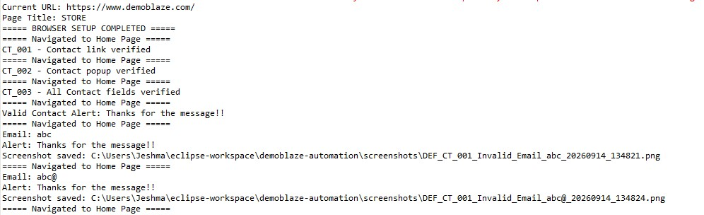Description:
Contact option was opened and the Contact form was verified.
Expected:
Contact modal should open and fields should be available for user input.
Actual:
Contact functionality worked as expected.
Status: PASS
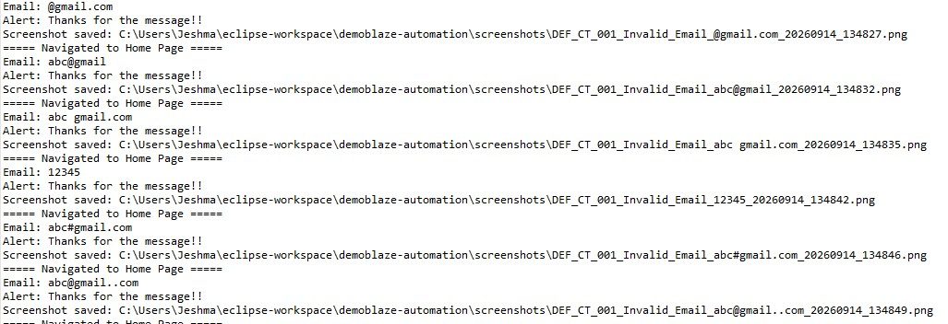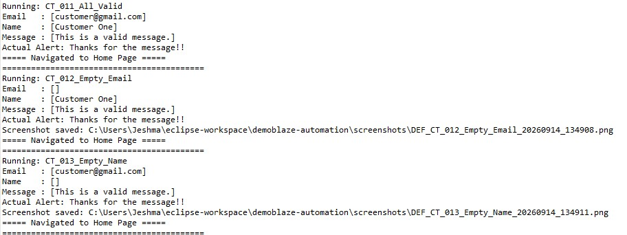
Description:
The user attempts to send the Contact form without entering the required fields.
Expected:
The application should display validation messages and should not allow the message to be submitted with blank mandatory fields.
Actual:
The application allows the Contact form to be submitted without entering the required information.

5.14 About Us Execution
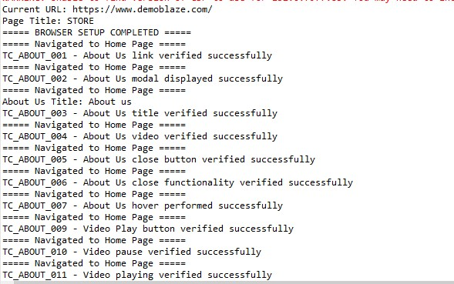
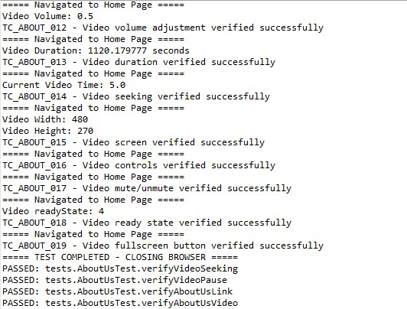

Description:
About us option was selected and the About Us modal was verified.
Expected:
About Us information should be displayed.
Actual:
About Us information was displayed successfully.
Status: PASS

5.15 Pagination Execution
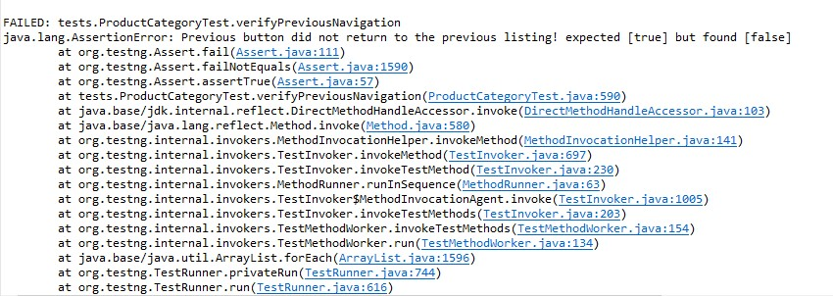Description:
Next and Previous pagination functionality was tested.
Expected:
Next should display the next set of products and Previous should return to the previous set.
Actual:
Pagination functionality not worked as expected.
Status: FAIL

6. Defect Summary
Defect ID | Module | Defect Description | Severity | Priority | Status
DEF_001 | Logout | Logout success message is not displayed | Minor | Low | NEW
DEF_002 | Login | Forgot Password option is not available | Minor | Low | NEW
DEF_003 | Login | Clear validation message is not displayed when Username is empty | Minor | Low | NEW
DEF_004 | Login | Clear validation message is not displayed when Password is empty | Minor | Low | NEW
DEF_005 | Login | Password visibility / Show Password option is not available | Minor | Low | NEW
DEF_006 | Contact | Invalid email address is accepted | Major | Medium | NEW
DEF_007 | Contact | Blank email ID is accepted | Major | Medium | NEW
DEF_008 | Contact | Invalid name is accepted | Minor | Low | NEW
DEF_009 | Contact | Blank name is accepted | Minor | Low | NEW
DEF_010 | Contact | Invalid message is accepted | Major | High | NEW
DEF_011 | Contact | Blank message is accepted | Major | High | NEW
DEF_012 | Contact | Message can be sent with only Email provided | Minor | Low | NEW
DEF_013 | Contact | Message can be sent with only Name provided | Minor | Low | NEW
DEF_014 | Contact | Message can be sent with only Message provided | Minor | Low | NEW
DEF_015 | Contact | Message can be sent with all mandatory fields blank | Major | High | NEW
DEF_016 | Product Category | Product card does not show hover effect | Minor | Low | NEW
DEF_017 | Product Category | Search field/button is not available | Major | Medium | NEW
DEF_018 | Product Category | Next button navigation is not as expected | Major | High | NEW
DEF_019 | Product Category | Previous button navigation is not as expected | Major | High | NEW
DEF_020 | Cart | No alert is displayed when attempting purchase with an empty cart | Critical | High | NEW
DEF_021 | Purchase | Invalid names are accepted in Purchase popup | Major | High | NEW
DEF_022 | Purchase | Invalid country is accepted in Purchase popup | Major | High | NEW
DEF_023 | Purchase | Invalid city name is accepted in Purchase popup | Major | High | NEW
DEF_024 | Purchase | Invalid credit card details are accepted in Purchase popup | Major | High | NEW
DEF_025 | Purchase | Invalid month is accepted in Purchase popup | Major | High | NEW
DEF_026 | Purchase | Invalid year is accepted in Purchase popup | Major | High | NEW
DEF_027 | Purchase | Card number is displayed in order confirmation message | Major | High | NEW

7. Observations
- Major e-commerce workflows were successfully tested.
- Product categories and product information were verified.
- Add to Cart functionality worked correctly.
- Cart product name and price were verified.
- Cart deletion functionality worked correctly.
- Checkout workflow was tested with valid data.
- Negative checkout scenarios were also tested.
- An issue was identified where the Place Order option is accessible with an empty cart.
- Input validation should be reviewed for checkout fields.

8. Overall Result
- Most tested functionalities worked as expected.
- Product browsing and category functionality worked correctly.
- Cart functionality was successfully validated.
- Checkout functionality was tested using positive and negative scenarios.
- High-priority issue identified in the empty-cart checkout flow.
- Automation execution was performed using Selenium WebDriver and TestNG.
- Defects identified during testing were documented separately.

9. Conclusion
The DemoBlaze application was tested for its major e-commerce functionalities using functional and automation testing approaches.
The testing covered Signup, Login, Home Page, Product Categories, Product Details, Cart, Checkout, Contact, and About Us modules.
Most of the tested functionalities worked as expected. However, an issue was identified in the Cart/Checkout workflow, where the user can access the Place Order option even when the cart is empty.
The identified issues should be reviewed and fixed, followed by regression testing to ensure that the changes do not affect previously working functionality.

10. Recommendations
- Prevent checkout when the cart is empty.
- Strengthen mandatory field validation during checkout.
- Improve UI feedback and validation messages.
- Continue regression testing after defect fixes.
- Maintain stable Selenium locators.
- Continue using explicit waits for dynamically loaded elements.
- Maintain screenshots as evidence for failed and important test cases.

11. Automation Repository
Repository Name: DemoBlaze Automation Testing
Repository URL:
https://github.com/kj2018traders-art/demoblaze-automation.git

12. Final Test Status
Item | Status
Test Planning | ✅ Completed
Test Case Design | ✅ Completed
Automation Development | ✅ Completed
Functional Testing | ✅ Completed
Negative Testing | ✅ Completed
Regression Testing | ☐ To be performed after fixes
Defect Reporting | ✅ Completed
Test Execution Report | ✅ Completed
Final Sign-Off | ✅ Completed

Final Recommendation
☑ Conditional Approval – Pending Defect Fixes and Regression Testing
☐ Approved
☐ Not Approved

